Catalog

**Ghost(2 variation)**

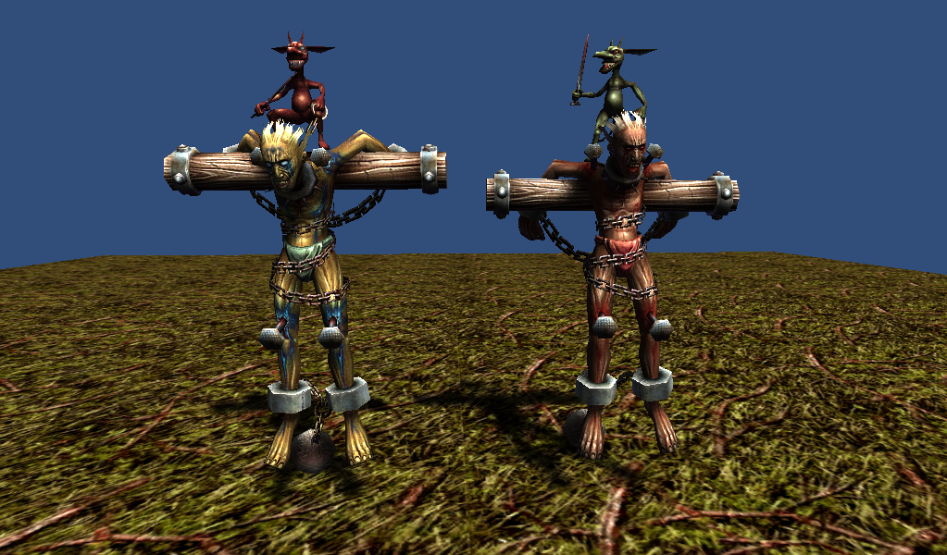

2922 polygons  
512x512x32bit 1 texture

256x256x24bit 1 texture  
5 animations(idle, move, attack, beaten, die)

**Tree Scorpion (3 variation)**

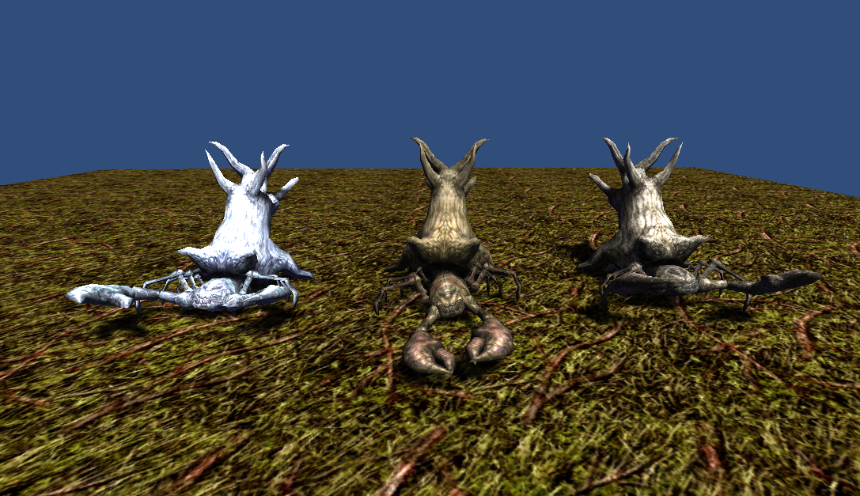

1576 polygons  
512x512x24bit 1 texture   
6 animations(idle, idle_defense, move, attack, beaten, die)

**Beholder(4 variation)**

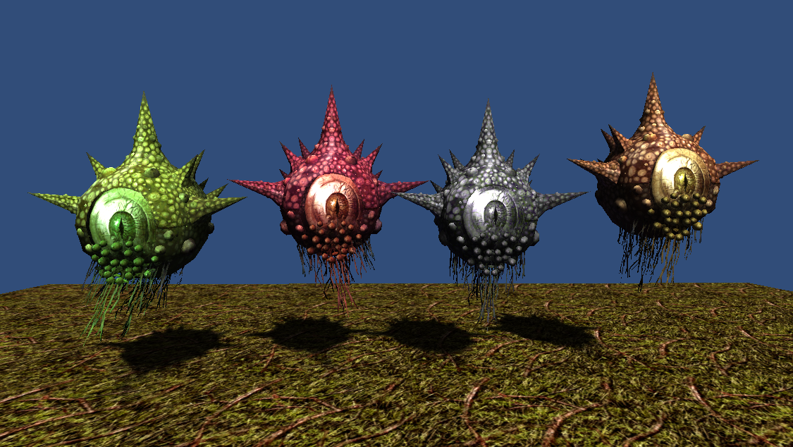

1821 polygons  
512x512x32bit 1 texture  
5 animations(idle, move, attack, beaten, die)

**Rock Giant(4 variation)**

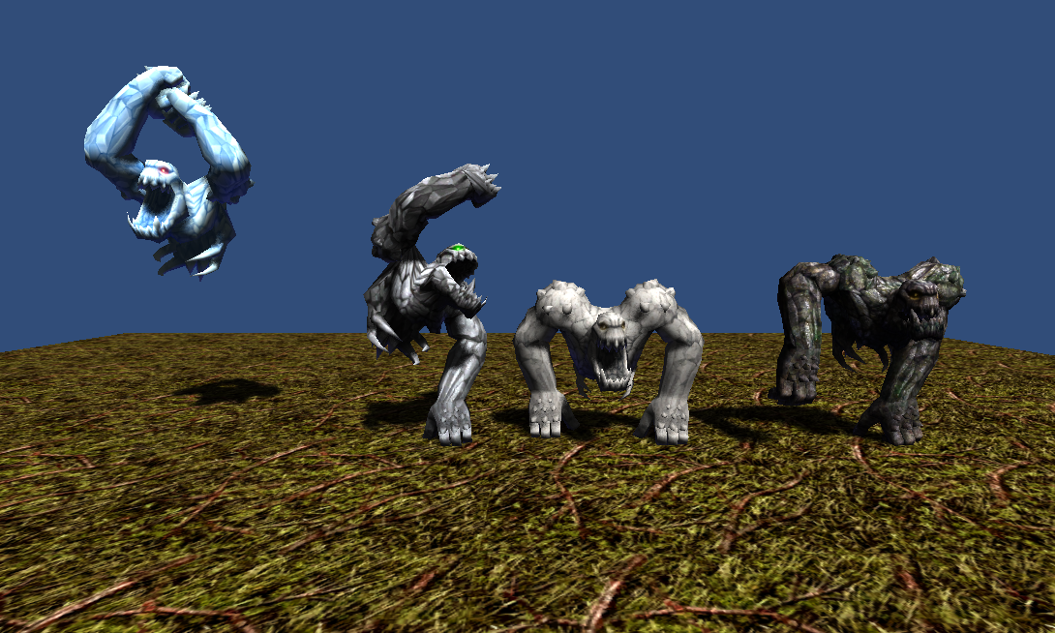

1232 polygons  
512x512x24bit 1 texture  
7 animations(idle, move, attack1, attack2, attack3, beaten, die)

**Thank you for download.**

**Contact**

Homepage : http://www.studioez.net

E-Mail : admin@studioez.net